A Report on

**Designing a CMOS OP-AMP**



By

Swagat Panda 2017B5A30983P

Deepak Jain 2017B5A30935P

Neelanchal Joshi 2017B5A30624P

Piyush Jain 2017B5A30944P

Submitted in partial fulfillment of the course

**EEE F313/ INSTR F313 - Analog and Digital VLSI Design**

Under the guidance of

**Prof. Anu Gupta,**

Dept. of Electrical and Electronics Engineering,

BITS Pilani

**Acknowledgement**

We would like to express our sincere gratitude towards Dr. Anu Gupta, Prof. Karri Babu Ravi Teja and the entire ADVD faculty along with the EEE department for their constant guidance and support in the project work.

We are also thankful to our batchmates and TAs for their help with software related issues and helping us understand the various steps, protocols and how to proceed with our project.

**Contents**

1. Problem Statement 4
2. Choosing the schematic 5
3. Calculations 6 – 7
4. Results 8 – 13
   1. Gain and phase plots 8
   2. Output Voltage Swings 8
   3. ICMR (Input Common Mode Range) 9
   4. Slew Rate 9
   5. Settling Time 10
   6. CMRR (Common Mode Rejection Ratio) 10
   7. PSRR (Power Supply Rejection Ratio) 11
   8. Operating Point 11 – 13
   9. Stability Analysis 13
5. Analysis at different temperatures (0o C and 100o C) 14 – 20
   1. Bode Plots 14
   2. Output Swing 15
   3. ICMR 16
   4. Settling Time 17
   5. Slew Rate 17
   6. CMRR 18
   7. PSRR 18
6. Summary of Results 19
7. Problems faced during designing 20
8. Design Tips to Start 20

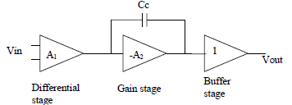**Problem Statement**

Design a CMOS OPAMP.

1. Analog schematic of the model shown alongside.
2. Analysis of all the equations of your design, with systematic derivations of all transistor W/L ratios and spectre simulations of circuit for the following simulations.
   1. Gain >= 100 dB
   2. Setting time <= 20 ns
   3. UGB >= 200 MHz
   4. Slew Rate <= 20 V/μs
3. STB analysis to calculate the closed loop gain and phase margin for the OPAMP.
4. Calculate and plot the following parameters for your OPAMP: DC Gain, Bode Plot for AC Gain and Phase, CMRR plot, ICMR plot, slew rate, settling time, output voltage swing (dc + transient), power consumption, and input and output offset voltage.
5. **CHOOSING THE SCHEMATIC:**

The schematic was designed based on the specifications provided in the question.

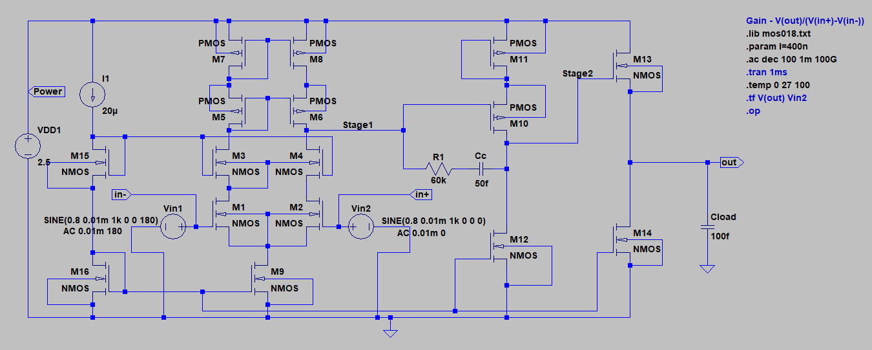

As shown in the schematic below, the first stage is the Differential stage, the second stage is the Gain stage, and the 3rd stage is a Buffer.

1. **CALCULATIONS:**

Determining the channel length modulation parameters for NMOS and PMOS models given to us.

NMOS

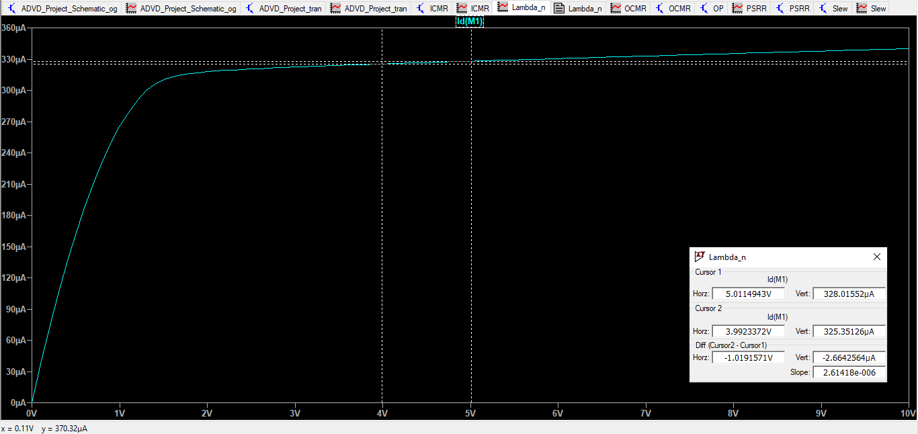

PMOS

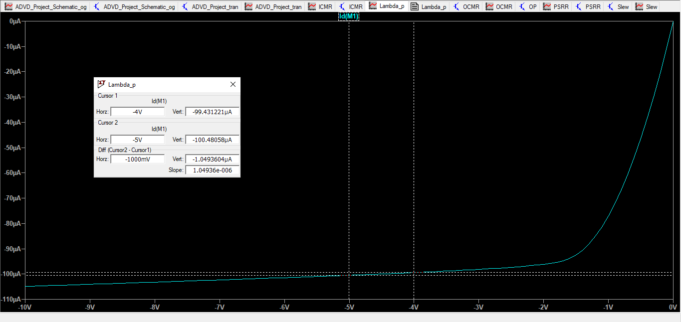

Value for λ was calculated by plotting Id vs Vds plot for a particular Vgs

**λpmos = 0.01**

**λnmos = 0.01**

Rough visualisation of how the approximate calculations should be carried out:

1. **RESULTS (all at 27oC):**
   1. Gain and Phase Plot:

Observed Values:

Gain = 102.09 dB

Gain Margin = 5.155 dB

Phase Margin = 52.35O

UGB = 213.79 MHz

3dB frequency = 701.57 Hz

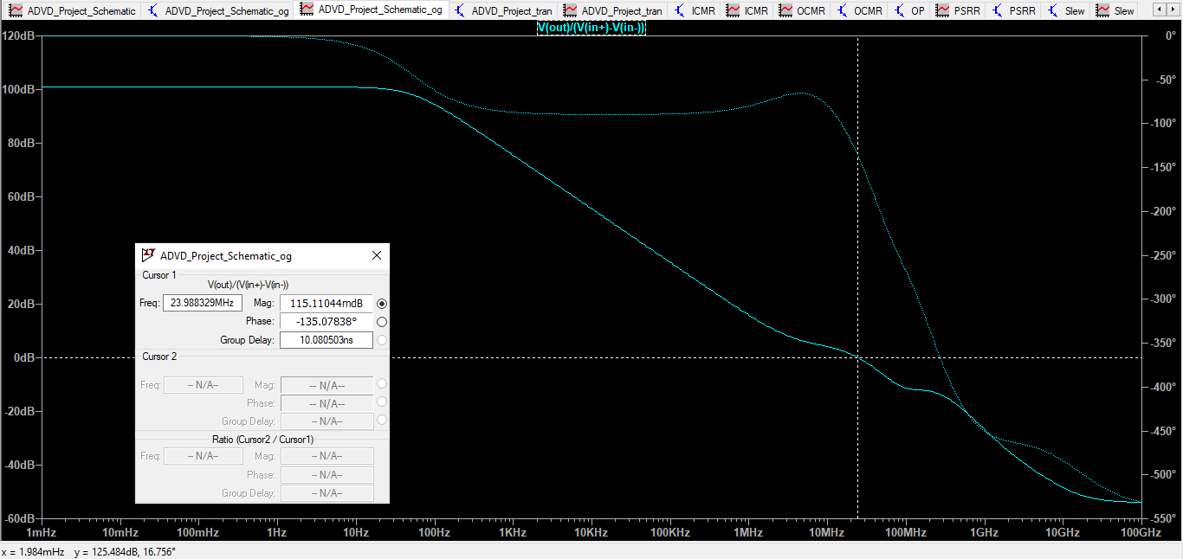

* 1. Output Voltage Swing:

Observed Values:

Vmax = 1.154 V

Vmin = 41.29 mV

**Swing** = Vmax – Vmin = 1.154 – 0.072 V = **1.082 V**

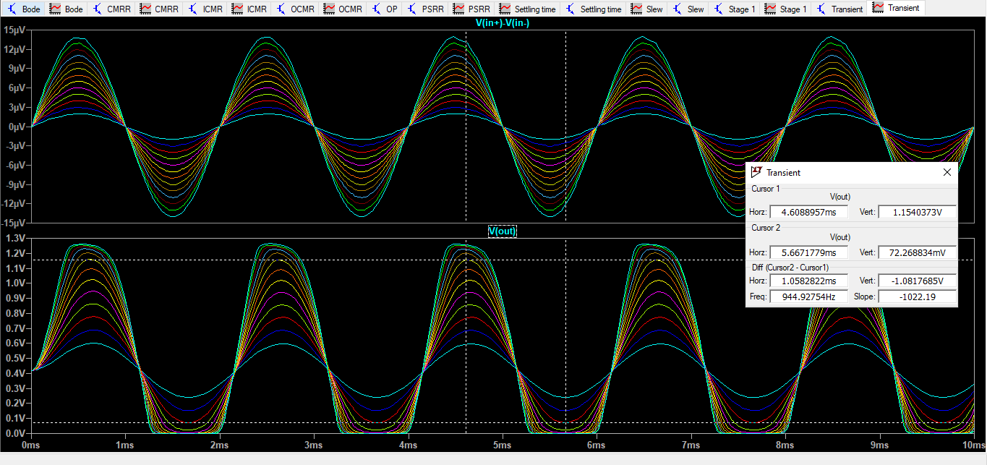

* 1. ICMR:

Observed Values:

Vin,min = 601.13 mV

Vin,max = 1.92 V

**ICMR** = Vin,max – Vin,min = 1.92 V – 0.601 V = **1.89 V**

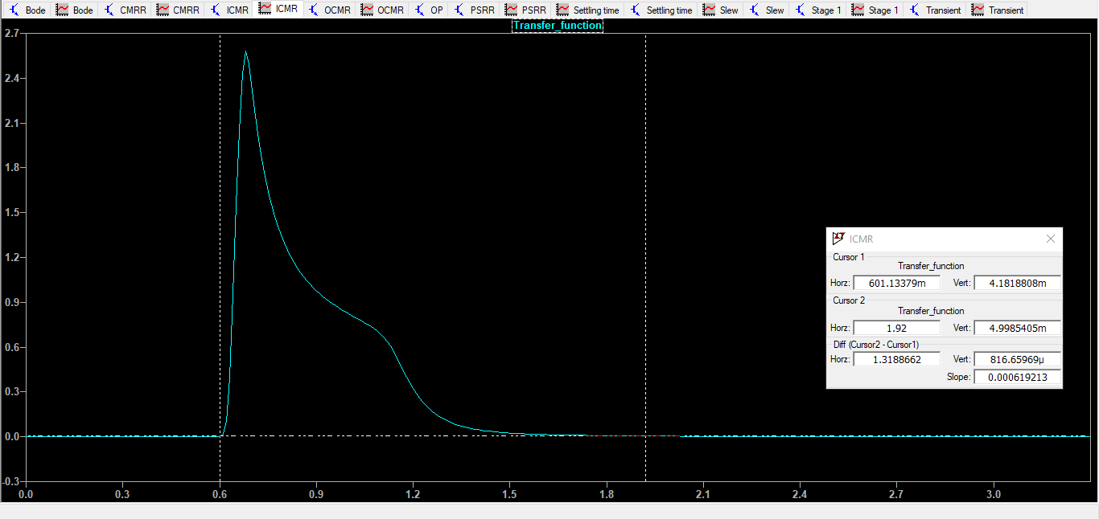

* 1. Slew Rate:

Observed Values: (for a 1V unit step pulse)

**Slope** = **10 V/μsec**

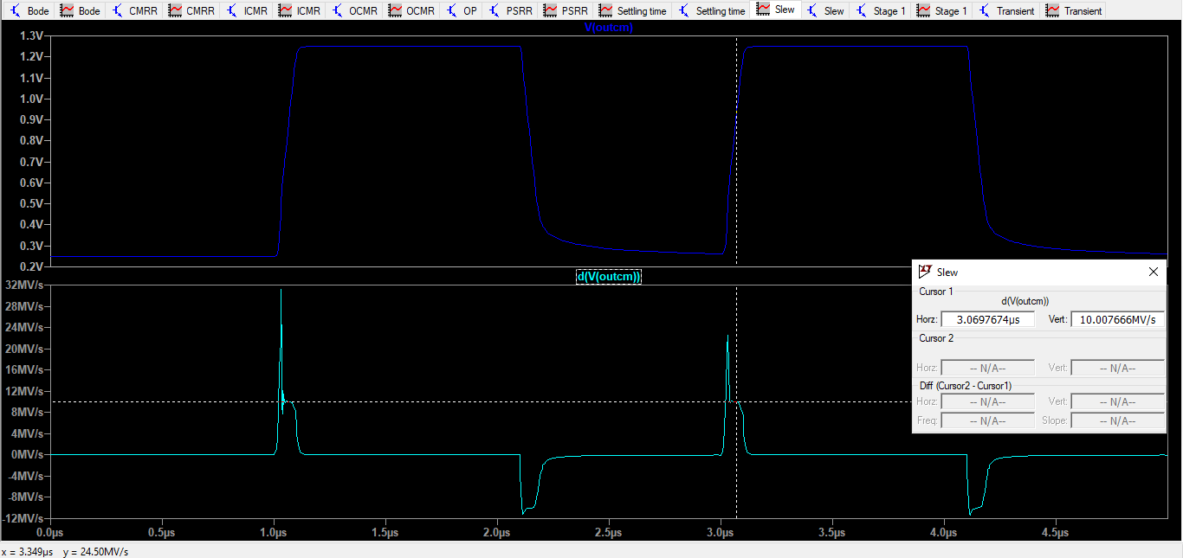

* 1. Settling Time:

Observed Value (1mV small signal used for settling time measurement):

**Settling Time = 12.135 ns**

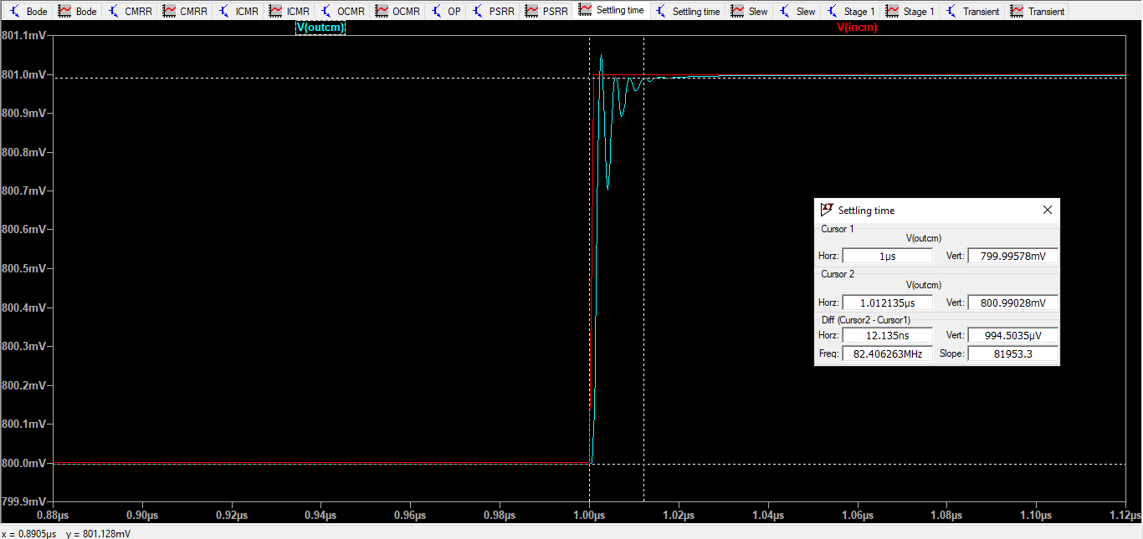

* 1. CMRR Plot:

Observed Value:

**CMRR = 99.19 dB**

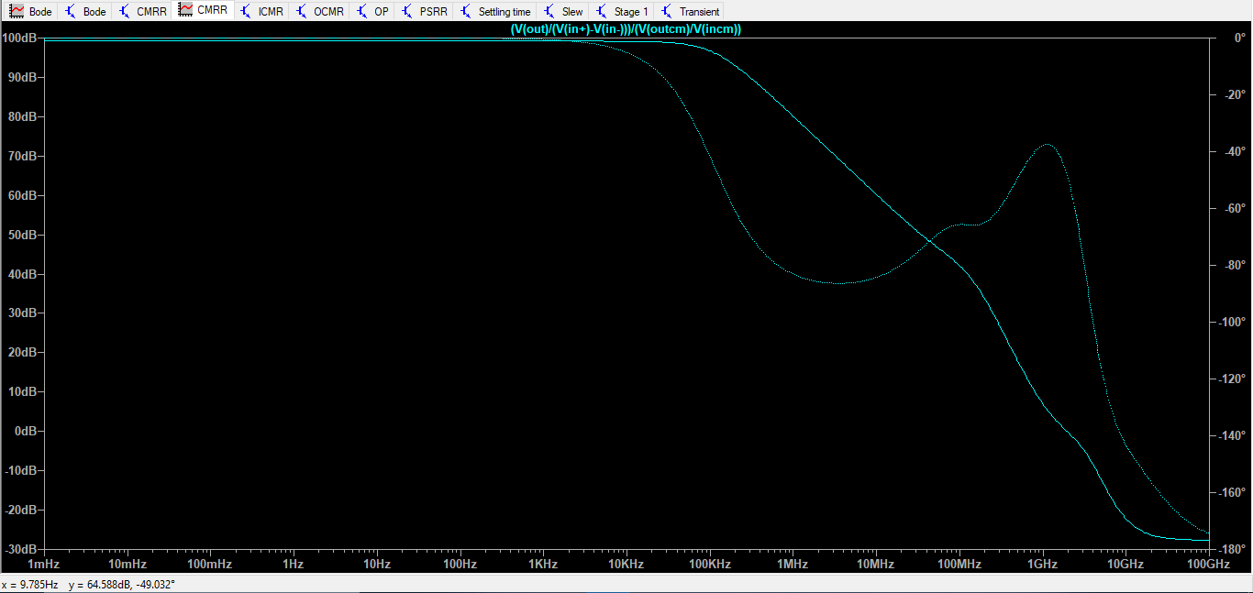

* 1. PSRR Plot:

Observed Value:

**PSRR = 148.18 dB**

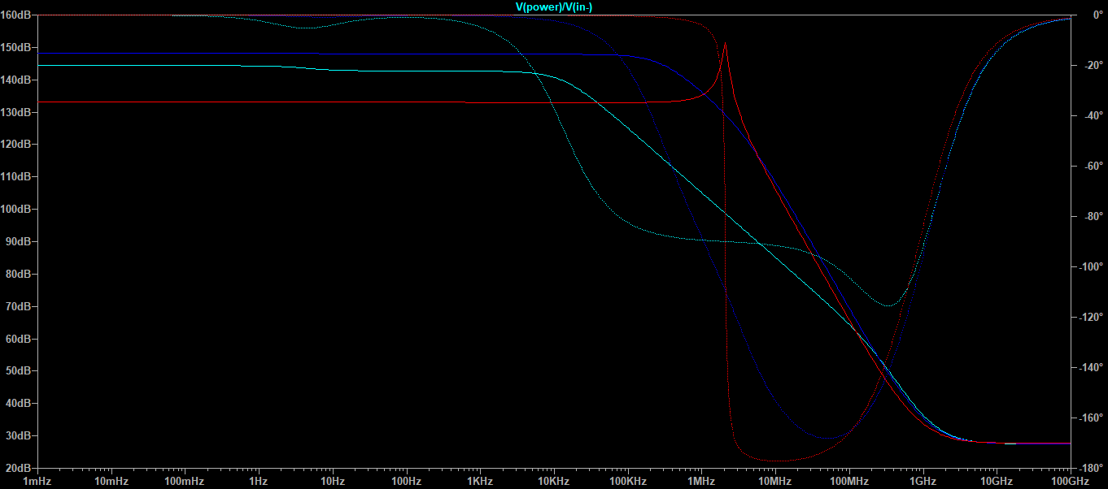

* 1. Operating Point:

Power Consumption(total) =

= 2.5 x 9.3631 x 10-5 W

**Power Consumption(total)** = **0.2409 mW**

**--- Operating Point ---**

**V(power): 2.5 voltage**

**V(stage2): 0.855464 voltage**

**V(out): 0.307116 voltage**

**V(n006): 0.520373 voltage**

**V(n007): 0.672094 voltage**

**V(in-): 0.8 voltage**

**V(n010): 0.256584 voltage**

**V(n009): 0.672092 voltage**

**V(in+): 0.8 voltage**

**V(n001): 1.95881 voltage**

**V(n003): 1.95881 voltage**

**V(n005): 1.21214 voltage**

**V(stage1): 1.36744 voltage**

**V(n004): 1.36763 voltage**

**V(n008): 1.36744 voltage**

**V(n002): 1.96551 voltage**

**Id(M16): -1.24487e-005 device_current**

**Ig(M16): -0 device_current**

**Ib(M16): 1.12005e-011 device_current**

**Is(M16): 1.24487e-005 device_current**

**Id(M15): -1.24487e-005 device_current**

**Ig(M15): -0 device_current**

**Ib(M15): 1.36122e-011 device_current**

**Is(M15): 1.24487e-005 device_current**

**Id(M14): -2.00872e-006 device_current**

**Ig(M14): -0 device_current**

**Ib(M14): 6.01177e-013 device_current**

**Is(M14): 2.00872e-006 device_current**

**Id(M13): -2.00872e-006 device_current**

**Ig(M13): -0 device_current**

**Ib(M13): 6.01362e-013 device_current**

**Is(M13): 2.00872e-006 device_current**

**Id(M6): -2.00872e-006 device_current**

**Ig(M6): -0 device_current**

**Ib(M6): 1.10239e-012 device_current**

**Is(M6): 2.00872e-006 device_current**

**Id(M5): -2.00872e-006 device_current**

**Ig(M5): -0 device_current**

**Ib(M5): 1.10238e-012 device_current**

**Is(M5): 2.00872e-006 device_current**

**Id(M12): 2e-005 device_current**

**Ig(M12): 0 device_current**

**Ib(M12): -7.01766e-013 device_current**

**Is(M12): -2e-005 device_current**

**Id(M11): 1.24487e-005 device_current**

**Ig(M11): 0 device_current**

**Ib(M11): -4.32732e-012 device_current**

**Is(M11): -1.24487e-005 device_current**

**Id(M10): 2.00872e-006 device_current**

**Ig(M10): 0 device_current**

**Ib(M10): -7.05538e-013 device_current**

**Is(M10): -2.00872e-006 device_current**

**Id(M9): 2.00872e-006 device_current**

**Ig(M9): 0 device_current**

**Ib(M9): -7.05348e-013 device_current**

**Is(M9): -2.00872e-006 device_current**

**Id(M8): 2e-005 device_current**

**Ig(M8): 0 device_current**

**Ib(M8): -5.30373e-013 device_current**

**Is(M8): -2e-005 device_current**

**Id(M7): 4.01743e-006 device_current**

**Ig(M7): 0 device_current**

**Ib(M7): -2.66584e-013 device_current**

**Is(M7): -4.01743e-006 device_current**

**Id(M4): 2.00872e-006 device_current**

**Ig(M4): 0 device_current**

**Ib(M4): -4.25508e-013 device_current**

**Is(M4): -2.00872e-006 device_current**

**Id(M3): 2.00872e-006 device_current**

**Ig(M3): 0 device_current**

**Ib(M3): -4.25509e-013 device_current**

**Is(M3): -2.00872e-006 device_current**

**Id(M2): 5.71649e-005 device_current**

**Ig(M2): 0 device_current**

**Ib(M2): -9.51347e-013 device_current**

**Is(M2): -5.71649e-005 device_current**

**Id(M1): 5.71649e-005 device_current**

**Ig(M1): 0 device_current**

**Ib(M1): -4.40577e-011 device_current**

**Is(M1): -5.71649e-005 device_current**

**I(C2): 3.07116e-026 device_current**

**I(C1): -2.5599e-026 device_current**

**I(I1): 2e-005 device_current**

**I(R1): 0 device_current**

**I(Vin2): 0 device_current**

**I(Vin1): 0 device_current**

**I(Vdd1): -9.36311e-005 device_current**

Output Offset Voltage (Operating point) = **0.2436 V**

Input Offset Voltage (Operating point) = **0.8 V > 0.26+0.36 V{ = Vgs -VT; to ensure operation in saturation}**

* 1. Stability Analysis:

Observed Values:

Gain = 102.09 dB

Gain Margin = 5.155 dB

Phase Margin = 52.35O

UGB = 213.79 MHz

3dB frequency = 701.57 Hz

The designed system is stable because the Phase Margin is high (greater than 45O) and so is the Gain Margin.

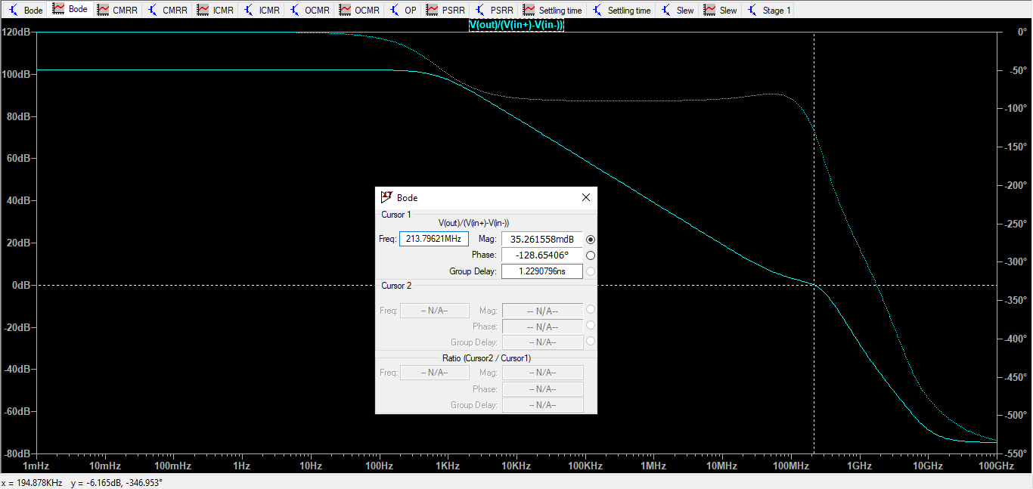

1. **ANALYSIS AT DIFFERENT TEMPERATURES (0 and 100o C):**
   1. Bode Plots:

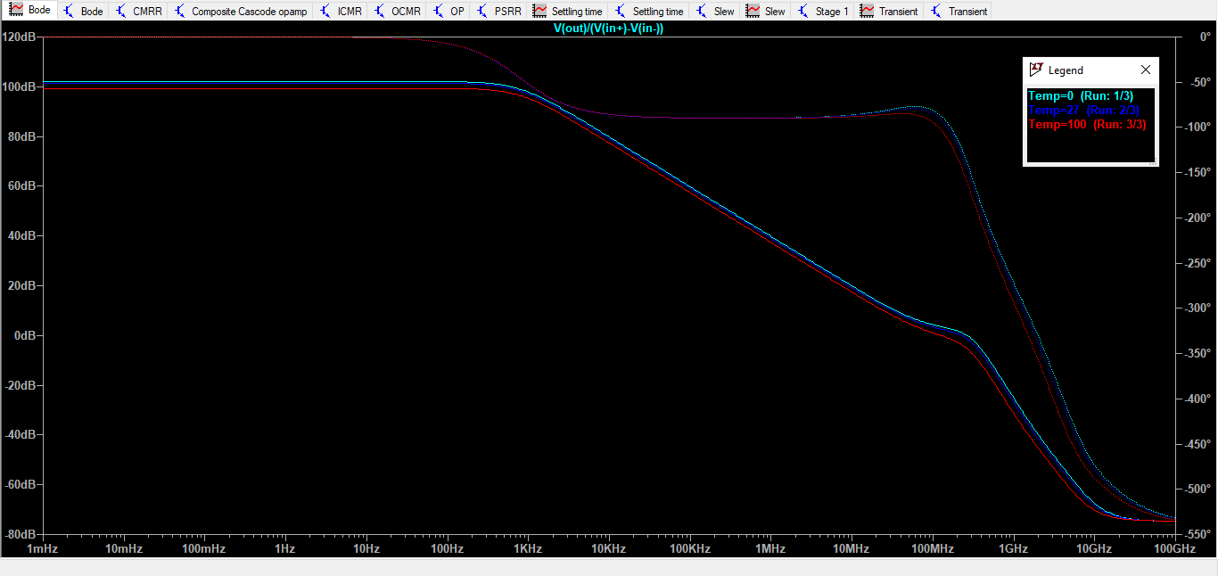

Temperature 0oC – DC gain – 102.75 dB

Temperature 100oC – DC gain – 100.14 dB

* 1. Output Swing:

Temperature – 0o C

Vmax = 1.202 V

Vmin = 35.23 mV

**Swing** = Vmax – Vmin = 1.202 – 0.035 V = **1.166 V**

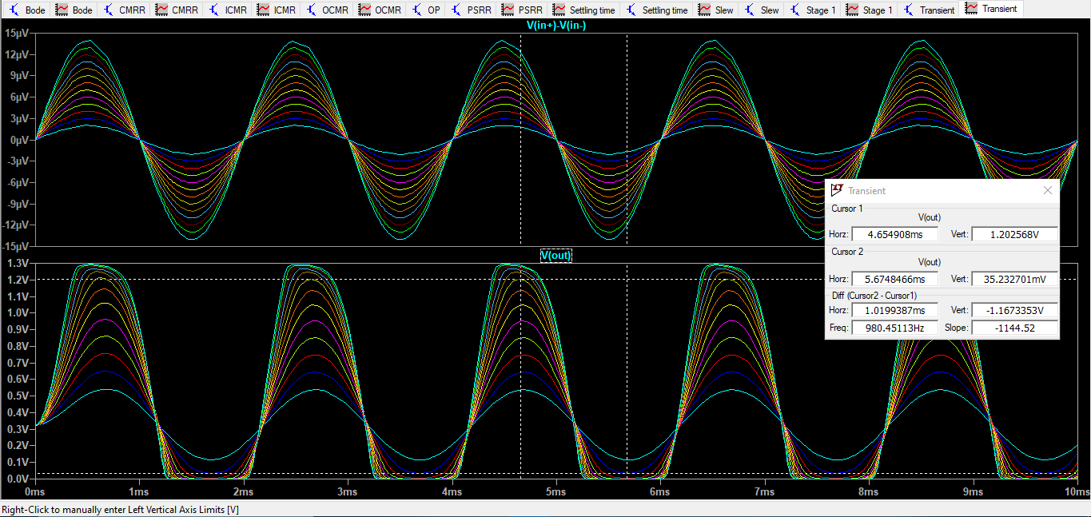

Temperature – 100o C

Vmax = 1.079 V

Vmin = 45.26 mV

**Swing** = Vmax – Vmin = 1.079 – 0.045 V = **1.034 V**

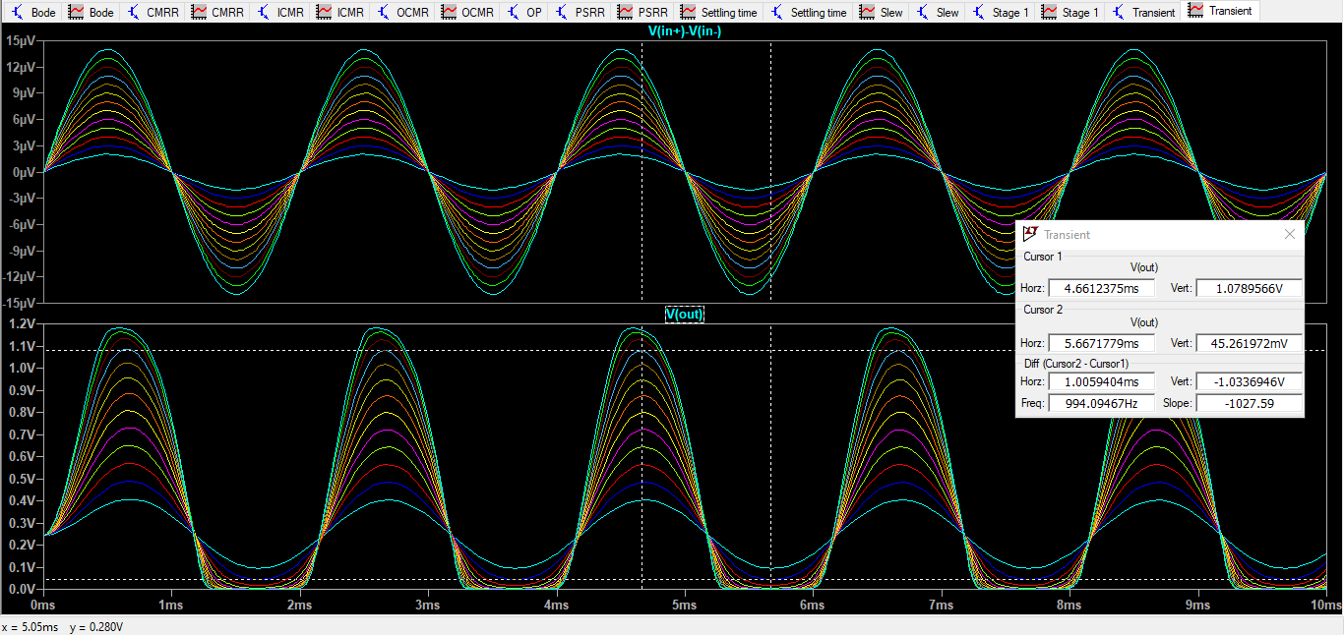

* 1. ICMR

Temperature – 0o Celsius

Vin,min = 597.89 mV

Vin,max = 1.645 V

**ICMR** = Vin,max – Vin,min = 1.645 V – 0.597 V = **1.047 V**

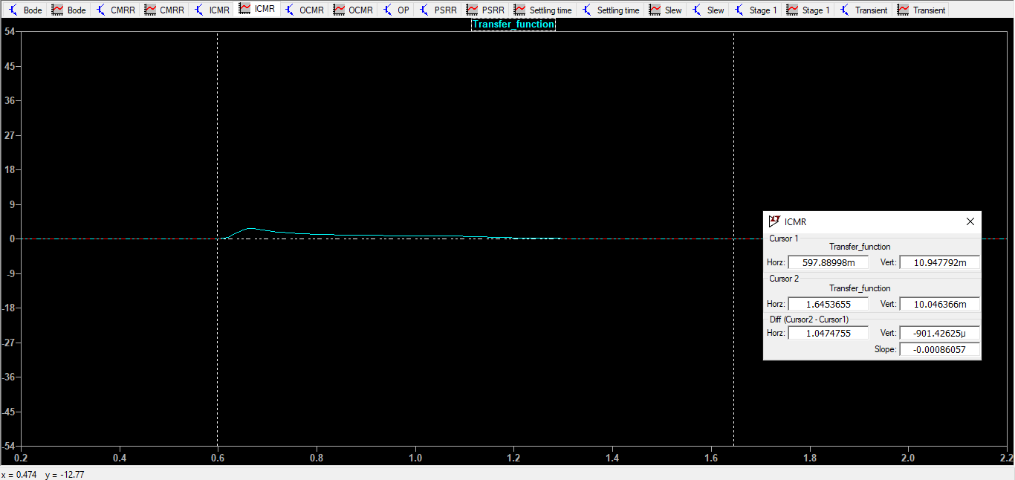

Temperature – 100o Celsius

Vin,min = 626.07 mV­­­

Vin,max = 2.102 V

**ICMR** = Vin,max – Vin,min = 2.102 V – 0.626 V = **1.476­V**

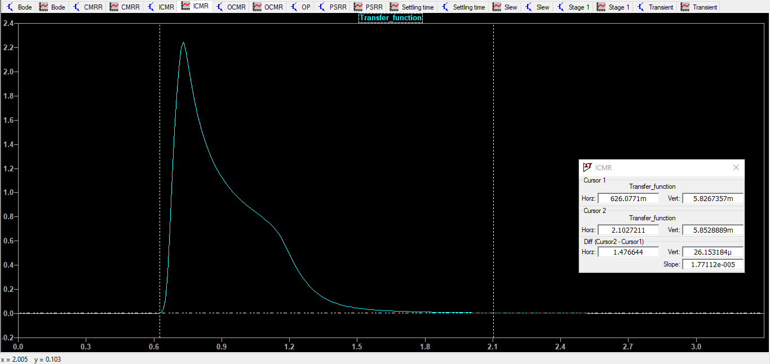

* 1. Slew Rate:

The Slew Rates for both positive and negative pulse for all Temperatures (0, 27 and 100 oC)

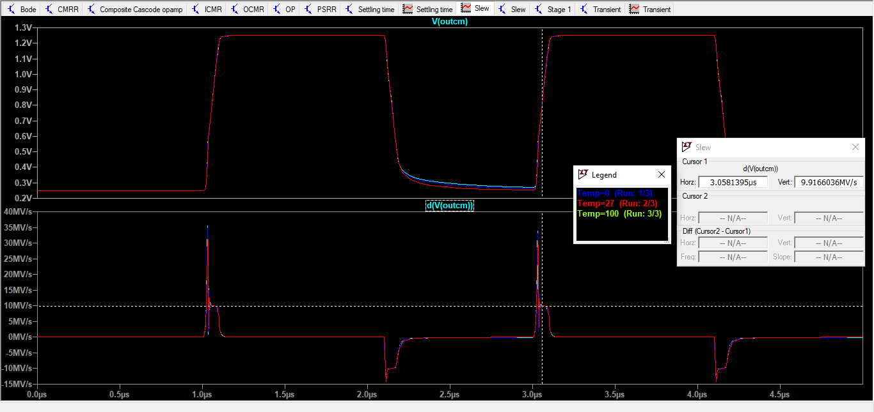

* 1. Settling Time

Temperature 0o C - **Settling Time = 8.704 ns**

Temperature 100o C - **Settling Time = 17.870 ns**

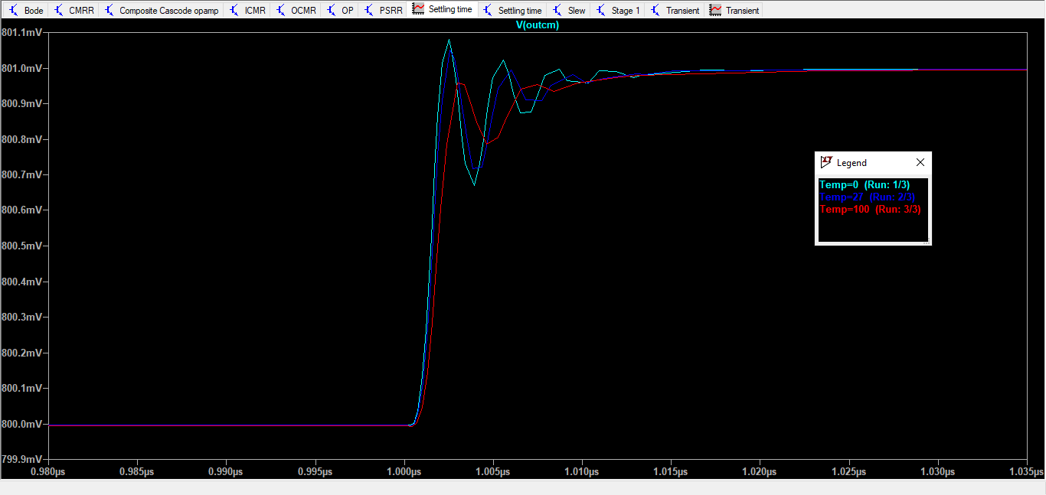

* 1. CMRR Plot

Temperature 0oC – DC gain – 100.52 dB

Temperature 100oC – DC gain – 95.33 dB

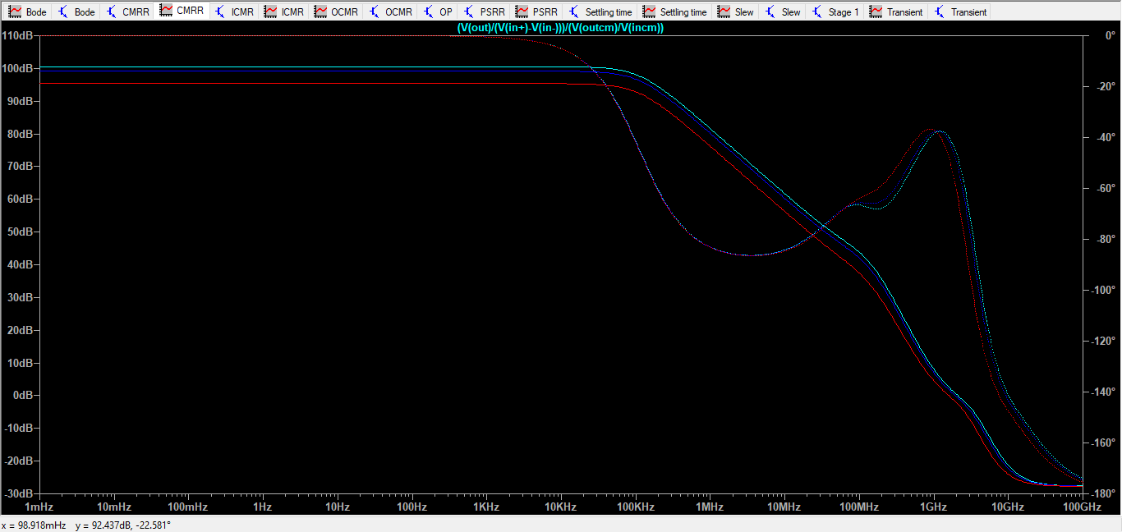

* 1. PSRR Plot:

Temperature 0oC – DC gain – 144.34 dB

Temperature 100oC – DC gain – 133.03 dB



1. **Summary of Results:**

The final W/L ratios used for simulation in LTSpice were as follows:

Where **lmin** was taken as **400 nm**.

|  |  |
| --- | --- |
| MOSFET | W/L RATIOS |
| M1 | 10/0.4 |
| M2 | 30/0.4 |
| M3 | 12.5/0.4 |
| M4 | 5/0.8 |
| M5 | 5/0.4 |
| M6 | 2/0.4 |
| M7 | 0.5/0.4 |
| M8 | 0.5/0.4 |
| M9 | 0.5/0.4 |
| M10 | 0.5/0.4 |
| M11 | 1/0.4 |
| M12 | 1/0.4 |
| M13 | 1/0.4 (m=2) |
| M14 | 1/0.4 (m=2) |
| M15 | 1/0.4 |
| M16 | 10/0.4 |

**Table 1:** W/L Ratio values for all MOSFETs (in μm, ‘m’ is the number of parallel devices)

|  |  |  |  |
| --- | --- | --- | --- |
| Sr.no. | Quantity | Value | Required |
| 1 | DC Gain | 102.09 dB | >= 100 dB |
| 2 | Output Voltage Swing | 1.082 V | - |
| 3 | ICMR | 1.89 V | - |
| 4 | Slew Rate | 10 V/ μsec | <= 20 V/μsec |
| 5 | Phase Margin | 52.35 O | ~60 O |
| 6 | Power Dissipation | 0.2409 mW | <= 3 mW |
| 7 | Output Offset Voltage | 0.2436 V | - |
| 8 | Input Offset Voltage | 0.8 V | - |
| 9 | CMRR | 99.19 dB | - |
| 10 | PSRR | 87.464 dB | - |
| 11 | -3dB | 701.57 Hz | - |
| 12 | UGB | 213.79 MHz | - |
| 13 | Settling Time | 12.135 ns | - |

**Table 2:** Summary of Results found and required values

1. **Problems faced during designing:**

* The MOS018.CIR file which was shared with us had errors and it took us significant amount of time to realize that. Therefore, its contents were corrected and copied into a .txt file and that file was used to simulate using LTSpice.
* The knowledge required for attempting and solving the problem asked in this assignment was neither taught in the lectures nor was it completely covered in the TA sessions.
* It was very challenging to meet all the specifications given in the problem statement simultaneously. Several trade-offs were employed to satisfy most of the constraints mentioned in the problem.
* All the constraints cannot be satisfied simultaneously, without proper guidelines, for example, the Settling time cannot be within 20ns for a large signal (~1V), with a slew rate < 20MV/sec and nothing is mentioned about finding settling time.

1. **Design Tips to Start**

* Choose the design schematic as per the gain requirements.
* Preferably keep the currents low for the high gain stages, such that the W/L values are not very large, and hence the poles and zeroes that occur are not at a very low frequency. (Low intrinsic capacitance values help in increasing the pole and zero frequencies)
* For the buffer stage, keep the gmro values of the buffer MOSFET as high as possible. (In case the buffer is made of a source follower)
* Use Miller compensation wherever required, keeping the values of the order of tens to of pF to tens of fF.
* Keep the number of stages <= the number of stages specified.
* With the given instructions, only one kind of NMOS CM or PMOS current mirror biasing is possible, stick to whatever you choose throughout the design.
* Input offset voltage is very important, it is often neglected, and the circuits don’t work.